**Exercise for introduction to databases**

**Problem Statement: There can be multiple customers, who can place multiple orders on the site. Now a sales person can handle these orders will distribute into multiple sales persons (One order will be assign to one salesperson only). So a sales person can have multiple orders of multiple customers.**

**1. Create Database**

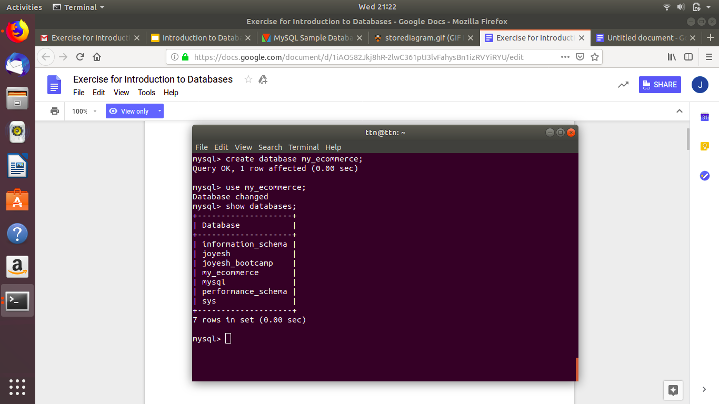

**2. Design Schema**

Keys for the tables :

customer primary key : cust_id

salesperson primary key : salesperson_id

orders composite key : order_id+cust_id+salesperson_id

ER Diagram :

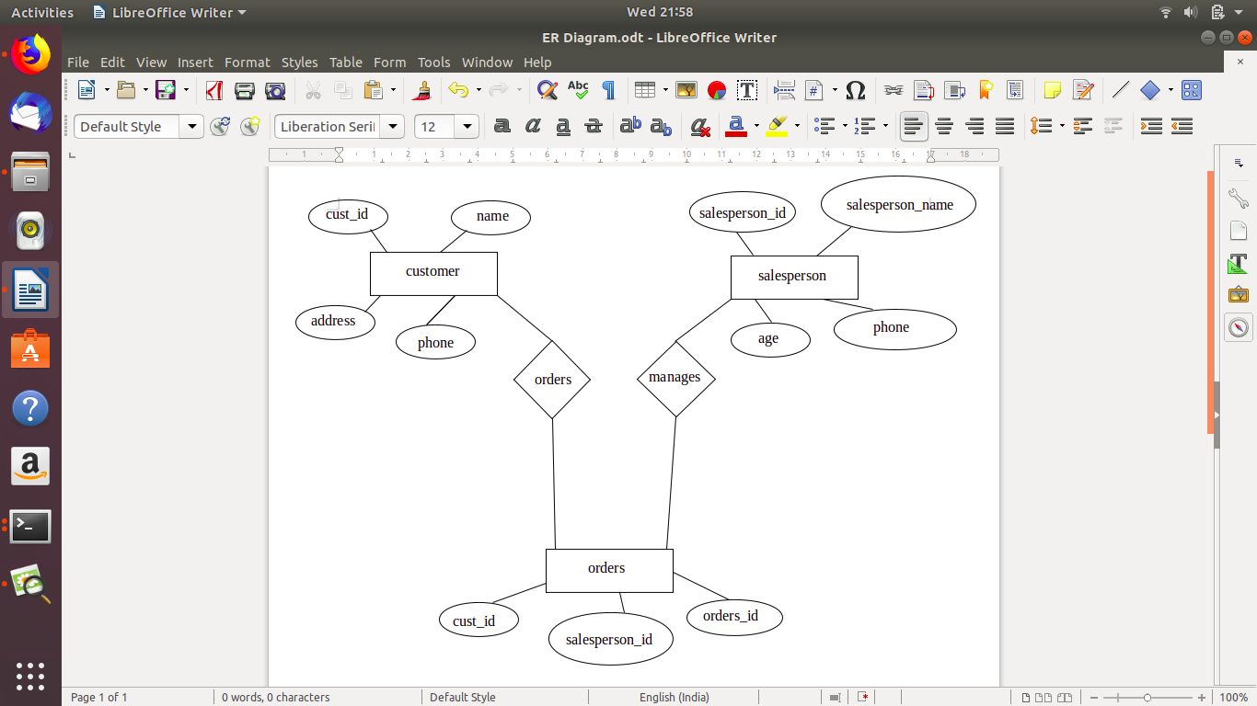

**3. Create tables**

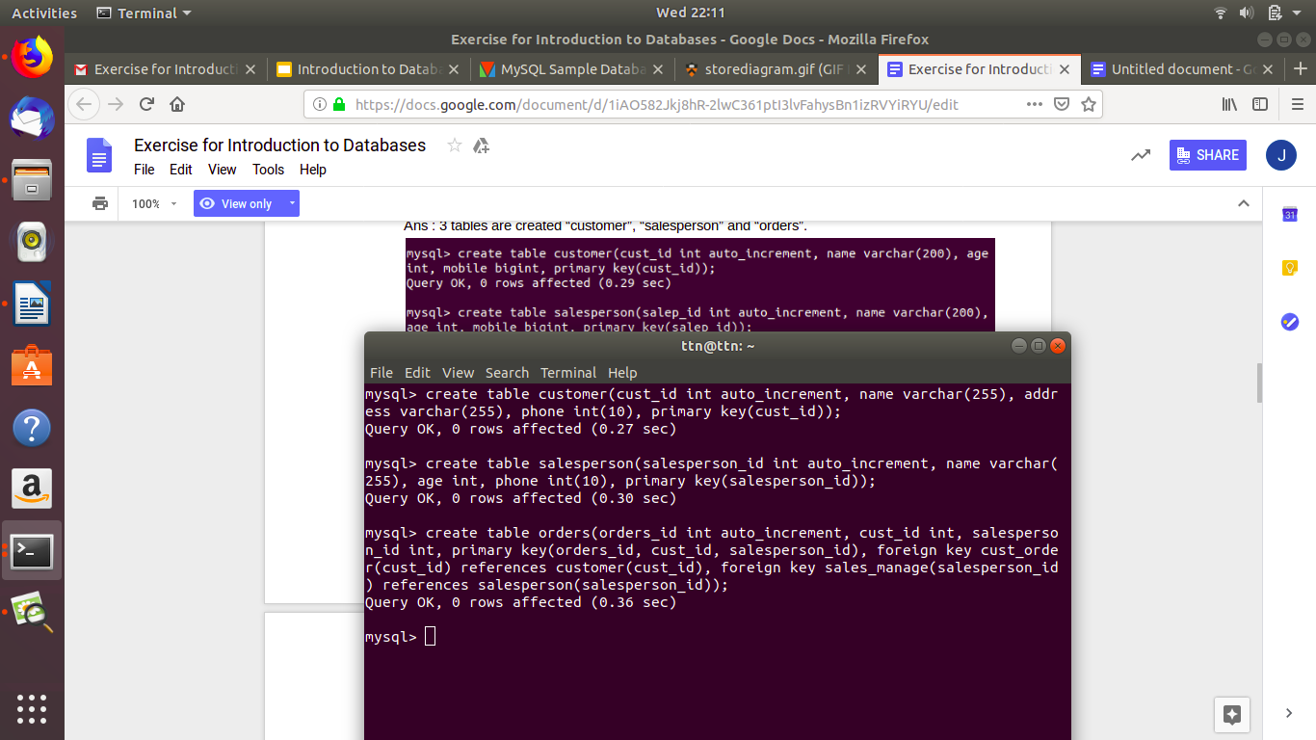

**4. Insert sample data**

Customer table :

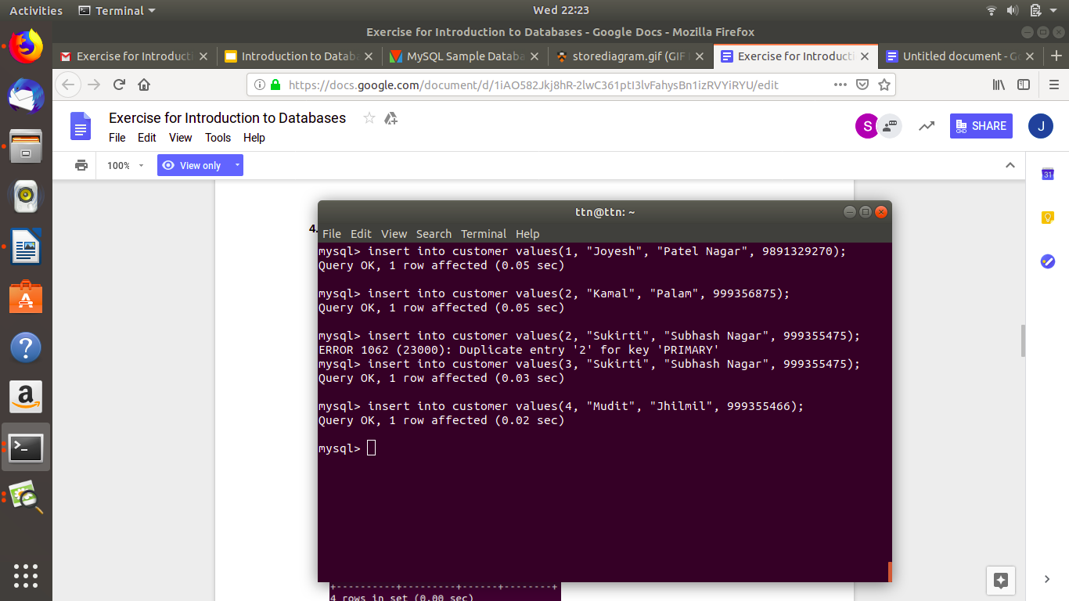

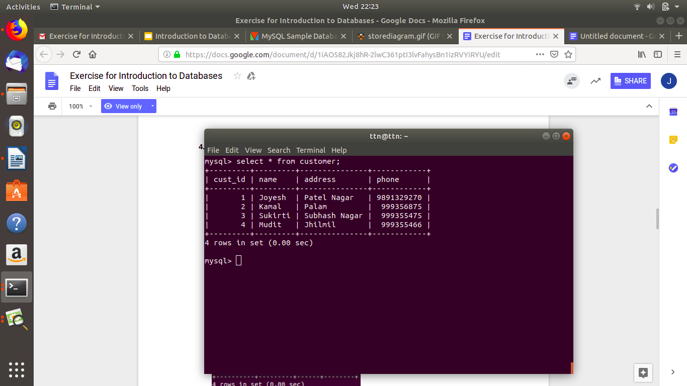

Salesperson table :

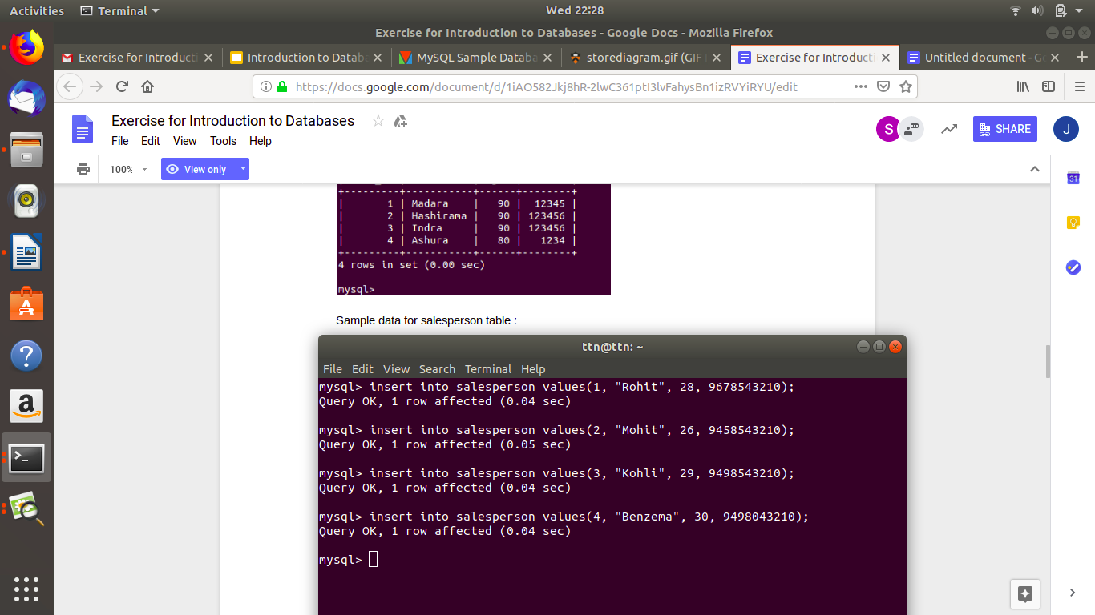

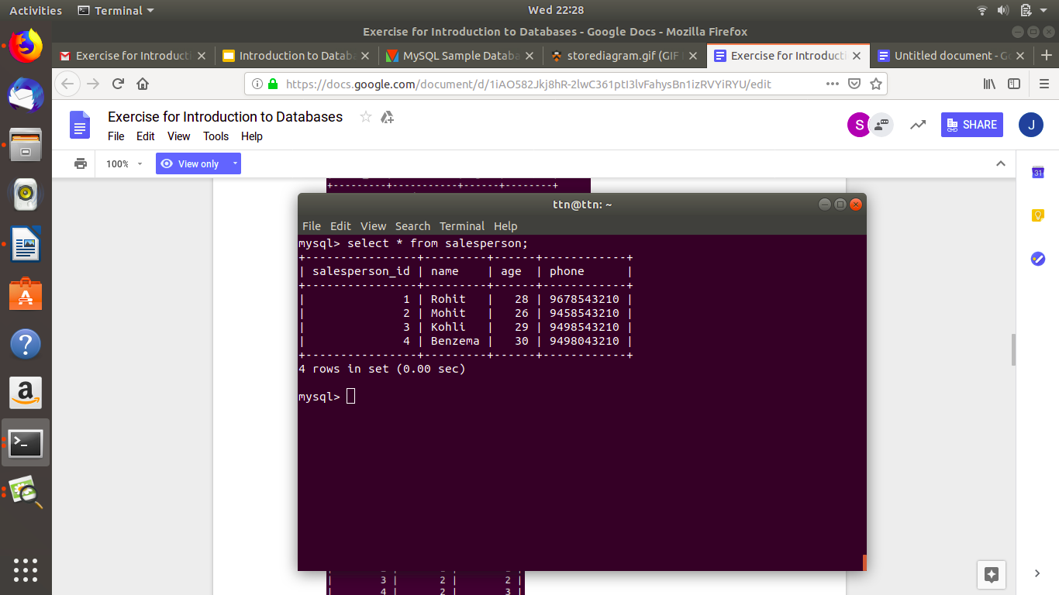

Orders Table :

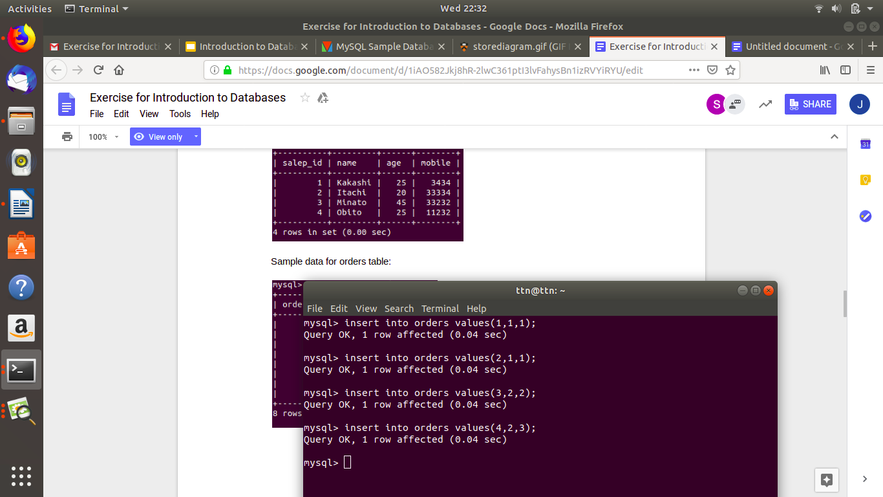

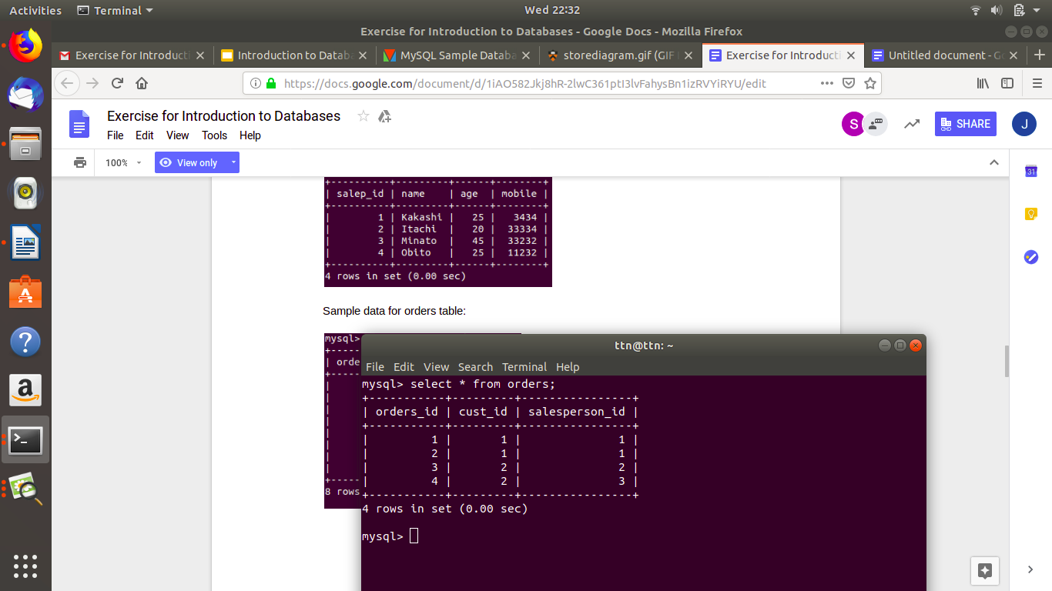

**5. Find the sales person who has multiple orders.**

In this problem nested query is being used which return only one salesperson because this salesperson is the only one who manages more than one order.

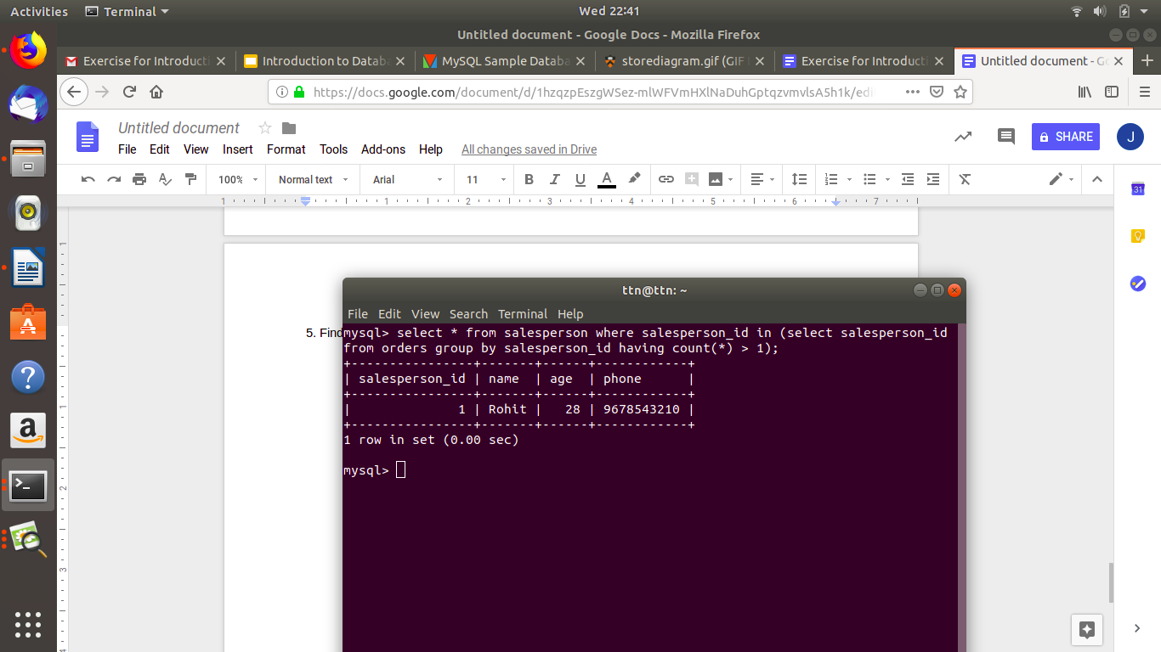

**6. Find the all sales person details along with order details**

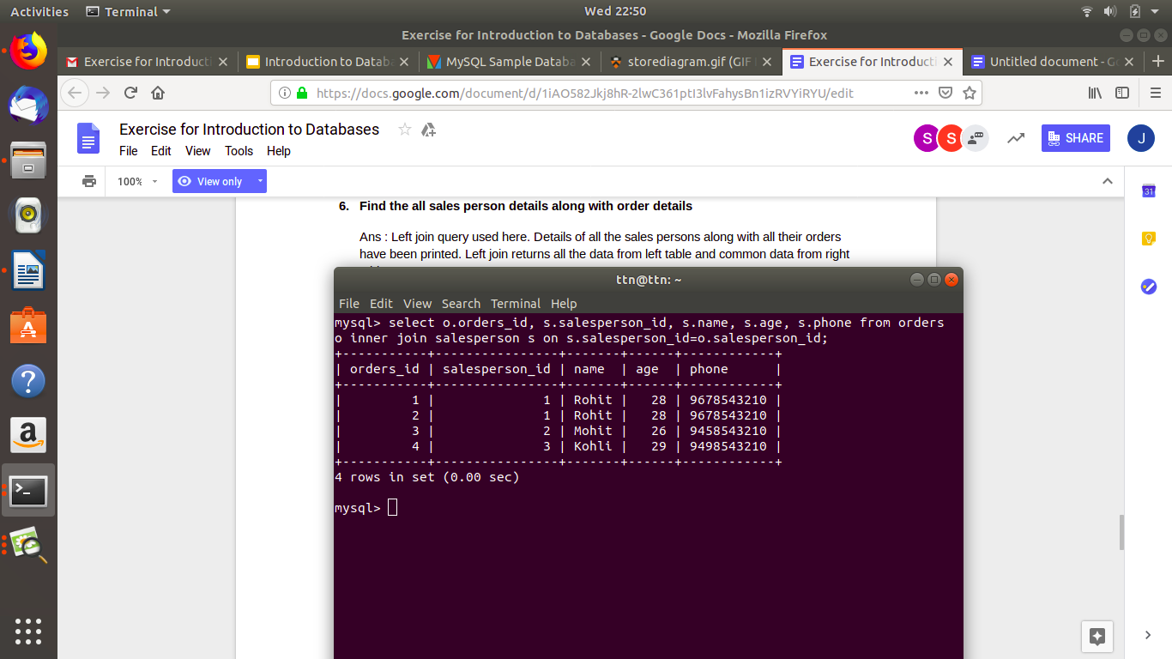

**7. Create index**

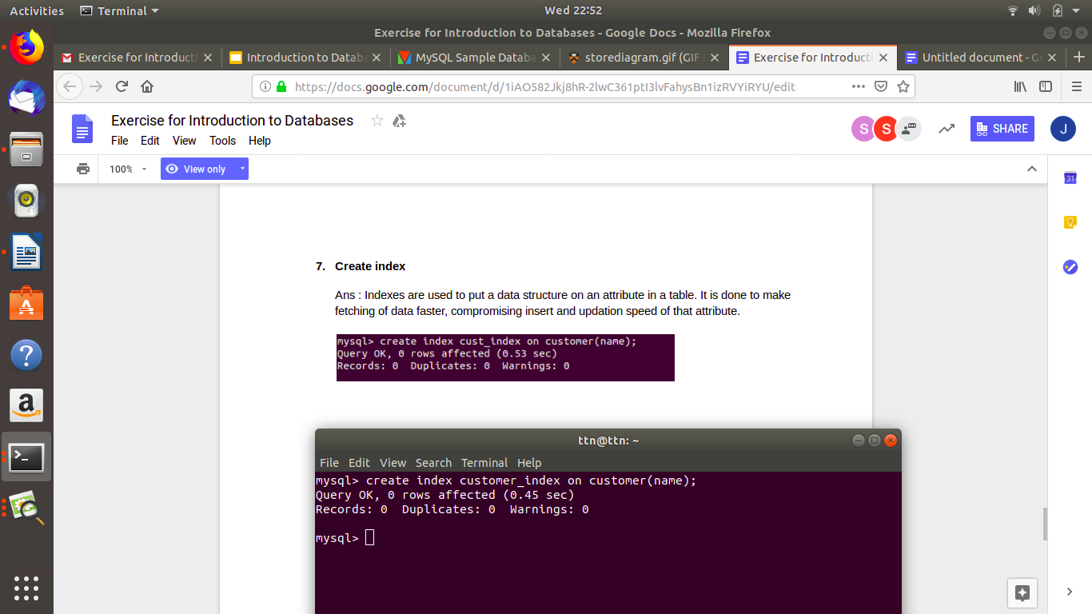

**8. How to show index on a table**

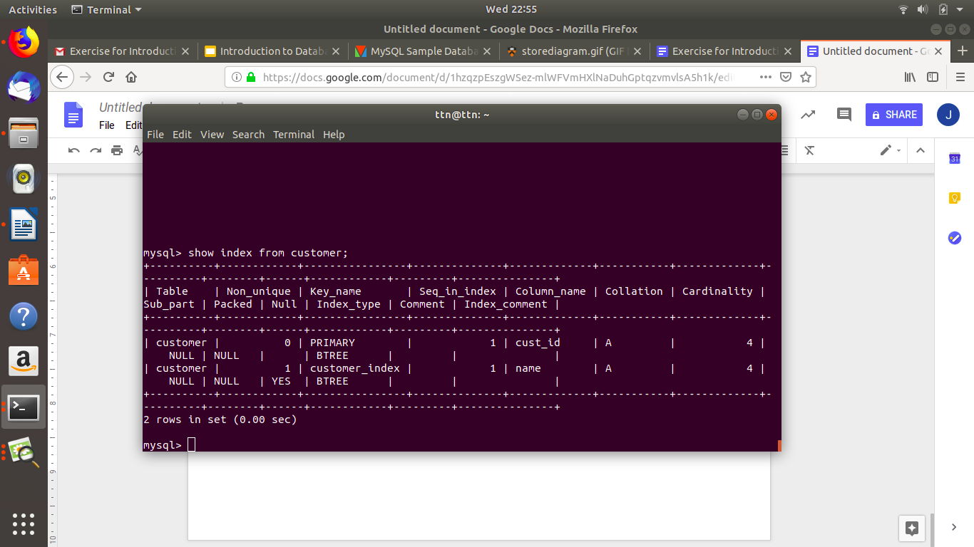

**9. Find the order number, sales person name, along with the customer to whom that order belongs to**

